https://cinea.ec.europa.eu/news-events/news/lyon-turin-rail-link-invests-more-eu3-billion-2021-07-07_en
News article 7 July 2021

Lyon-Turin rail link invests more than €3 billion
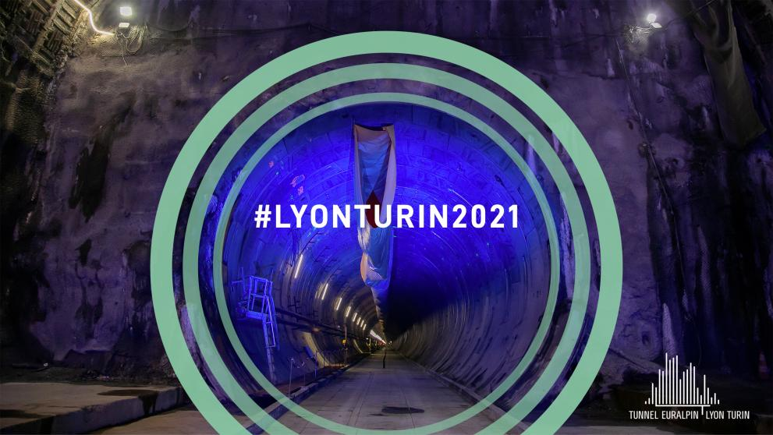
Lyon-Turin rail link
CINEA
The Lyon-Turin railway link is a cross-border railway connection between France and Italy with at its centrepiece an underground railway tunnel under the Alps. It is the main missing link along the TEN-T Mediterranean Corridor, which connects south-western Europe with central and eastern European countries.
Today, the board of directors of the body entrusted with building the cross border section of this railway connection (TELT - Tunnel Euralpin Lyon TurinEN•••) has awarded the major contracts to build the Lyon-Turin base tunnel in France.
Commissioner for Transport, Adina Vălean, said: "Today’s decision to award three contracts worth more than €3 billion is a significant step towards completing the Lyon-Turin rail connection. It will bridge a key missing link between France and Italy and help shift large volumes of cross-border traffic from road to rail. But it is more than a bi-national project, as it will become the nexus connecting the Iberian Peninsula to the Eastern part of the European Union. The Lyon-Turin rail connection is a long-awaited, well-thought-out, and highly emblematic European project, contributing to the objectives of the European Green Deal."
The tender procedure, divided into 3 lots for a total of €3 billion, represents one of the largest single tenders in Europe during the last two years. The works are supported by the Connecting Europe Facility (CEF) ProgrammeEN••• of the European Union (up to 40% of the total costs) and the European Climate, Infrastructure and Environment Executive Agency (CINEA) will continue to monitor the project.
The tunnel will be excavated from four construction sites in France (Saint Jean de Maurienne, Saint-Martin-La-Porte, La Praz and Villarodin-Bourget/Modane). TELT will oversee the works under the supervision of national control bodies as well as CINEA to ensure full compliance with technical requirements and relevant legislation. The start of these works in 2021 is particularly symbolic in a year designated as the European Year of Rail!EN•••
The Lyon-Turin railway tunnel will contribute to shift passengers and freight from road to rail, reduce congestion and transport costs, improve safety and lower emissions, in line with the European Green Deal. Once operational, the tunnel will allow the optimal functioning of the whole Mediterranean Corridor.

Relevant links
Lyon-Turin project information EN•••

Details
Publication date 7 July 2021

